

National University of Computer and Emerging Sciences Chiniot-Faisalabad Campus

Title: Project
Section: 6A-AI
lab: Database

Name | Roll no
Nehal | 22F-3090
Fatima | 22F-3179

GROUP MEMBERS:

Project Introduction:
The Game Store Application is a simple and user-friendly platform where users can browse, buy, and manage games online. Designed to function like a typical e-commerce website, this application allows users to create accounts, log in securely, and explore a wide variety of games based on genre or popularity.
Customers can easily add games to their shopping cart, place orders, and make secure payments. Admins can manage the game inventory, process orders, and track the sales data. The application also supports role-based access, ensuring that customers and admins have appropriate permissions for their tasks.

Home Page of user:
This is the homepage where all games will show.
The home page shows featured games. You can filter games by category (like Action or Adventure). Click on a game to see more details on the Product Details Page. You can also go to the Cart or Login Page from here.

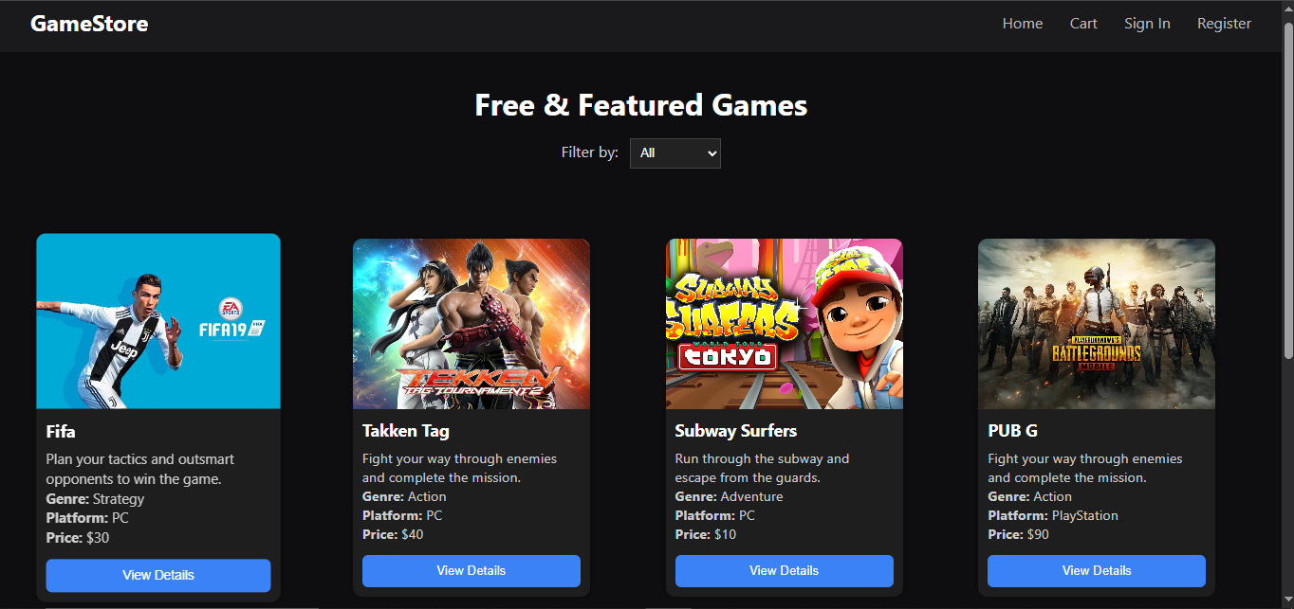

Detail Product page:

On this page detail of each game show and user will add them to cart from here.
Shows game information like title, description, price, and genre.

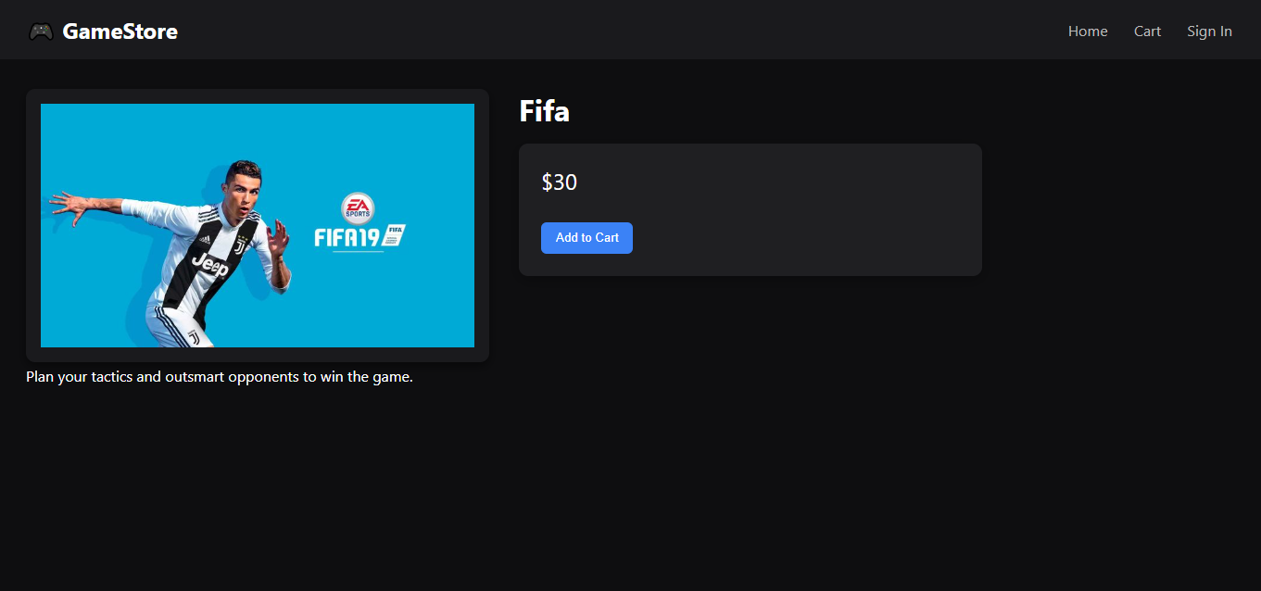

Cart:
This is the cart of our website user can also add new items to the cart or remove the existing item from the cart and also see the order summary and confirm order.
Shows the games you have selected, their quantity, and the total price.
You can change the quantity or remove items. There is also a button to go to the Order Summary Page
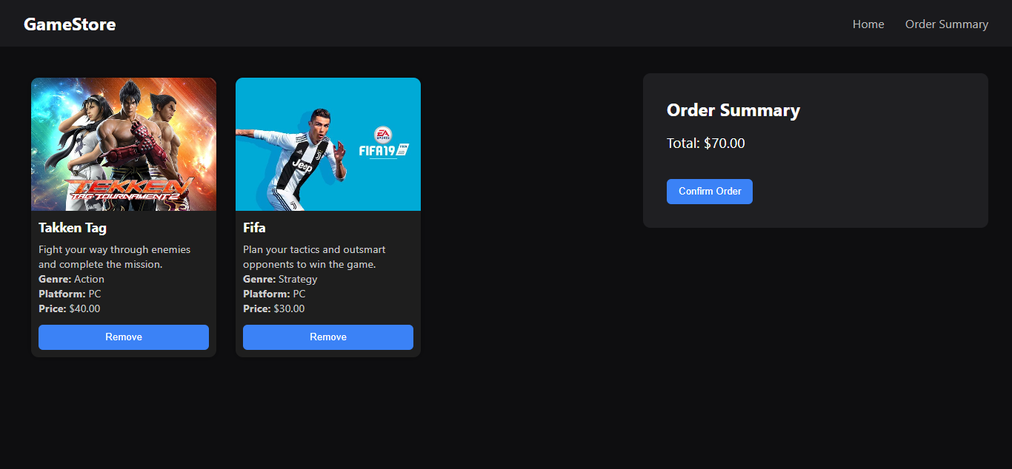

Order Summary:

This is the summary page where we show total cost of order and user can confirm order from here. Gives a final overview of your order, including games, quantity, and total cost.
You can confirm or cancel the order. Confirming takes you to the payment page.

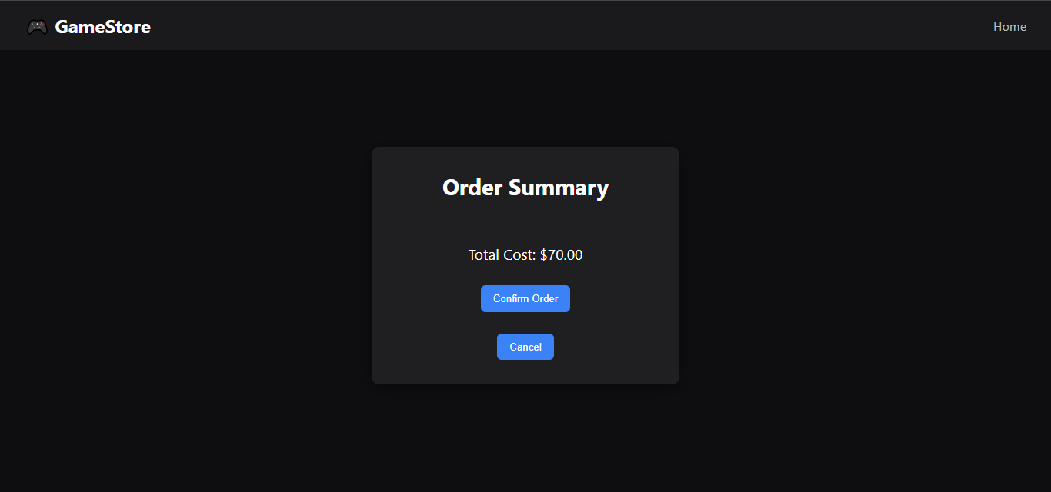

Authentication System:
Users can sign up or log in.
During signup, the system saves the password securely using encryption.
During login, the system checks the password with the one stored in the database.

Sign-In:
This is the sign in page for admin and user.
A simple form for users to create an account or log in.
It checks that the email and password are correct and meet the requirement
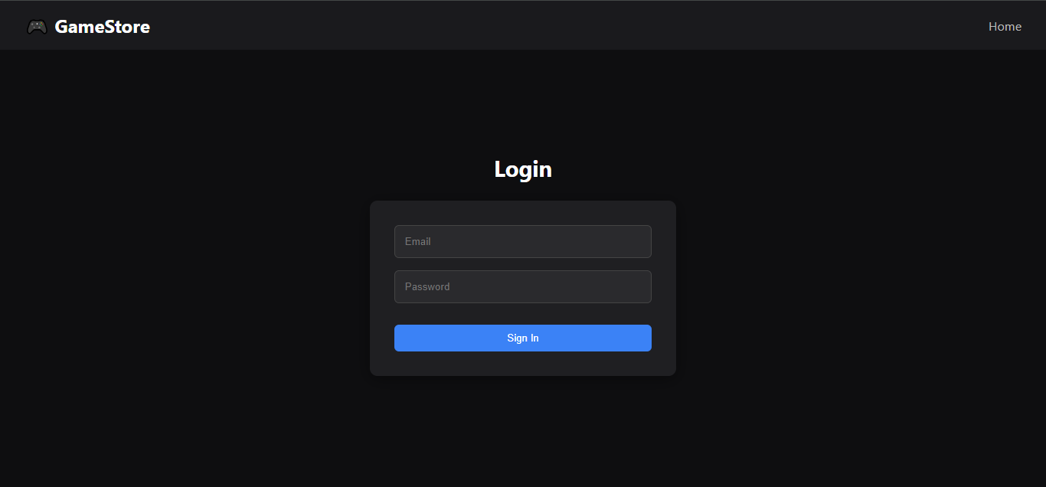

Register:
This is the register page to register new account. Password must be strong and 8 characters long and must contain at least 1 alphabet, 1 number 1 special character
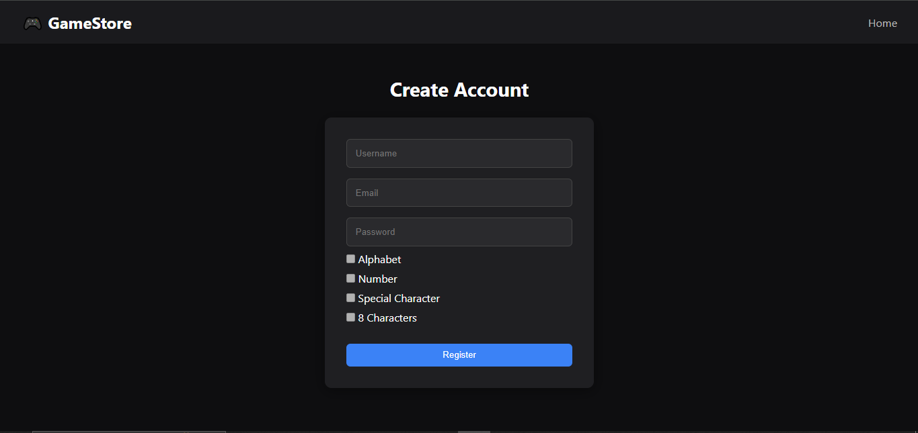

Role-Based Access:
There are two roles: Customer and Admin.
customer: Can browse games, view details, add to cart, and place orders.
Admin: Can add, update, or remove games, and manage orders.
The system checks the user's role before allowing access to certain features.

Admin Home:
This is the homepage of admin
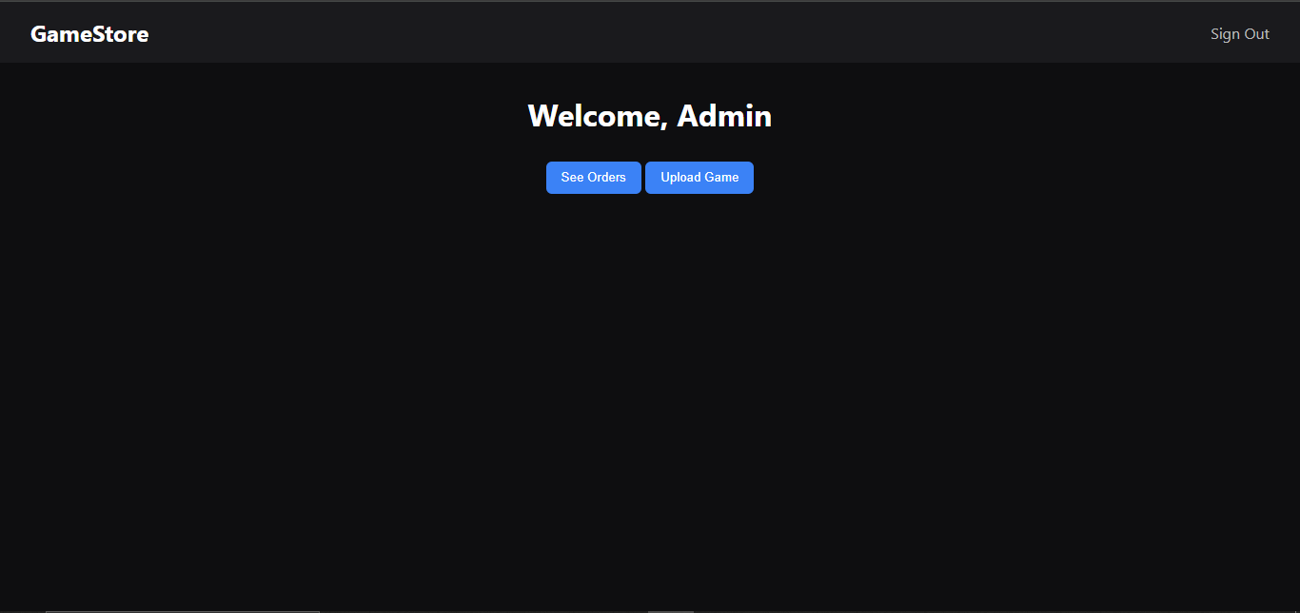

upload game:
From this page admin can upload new game chose image form it’s system
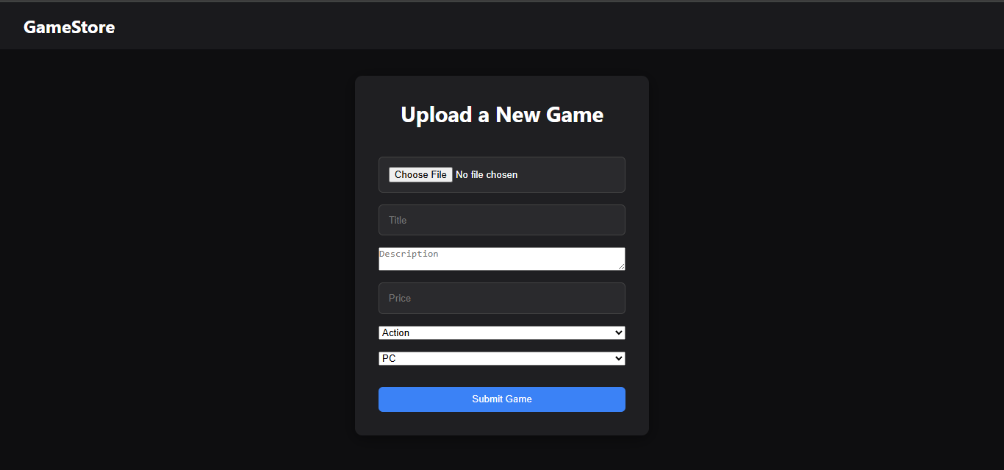

Order Detail:
This page shows all pending orders to admin and admin can also mark order as complete.
Shows a final list of your games, their quantities, and the total price.
ou can either confirm the order or go back to the cart

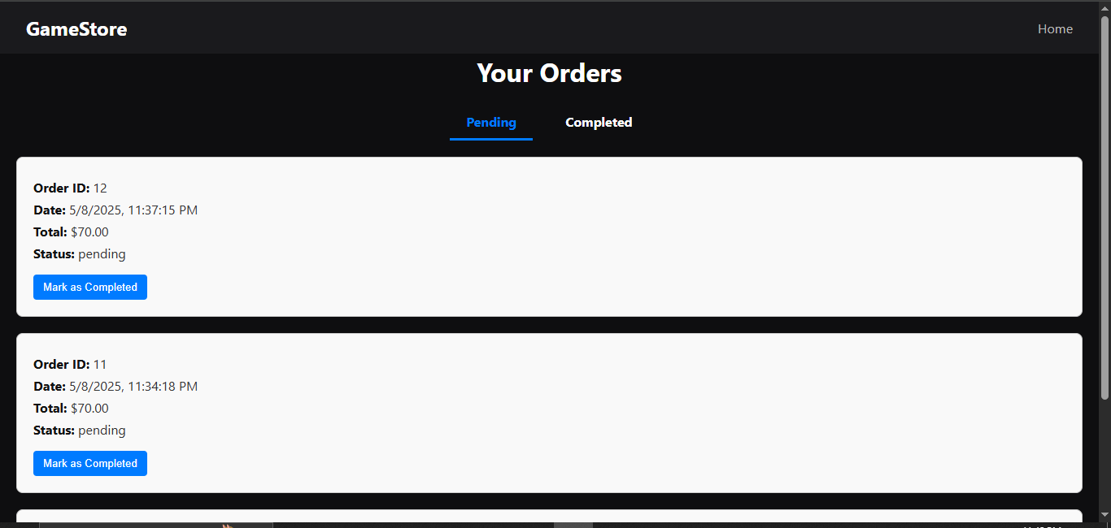
This page show all completed orders to admin
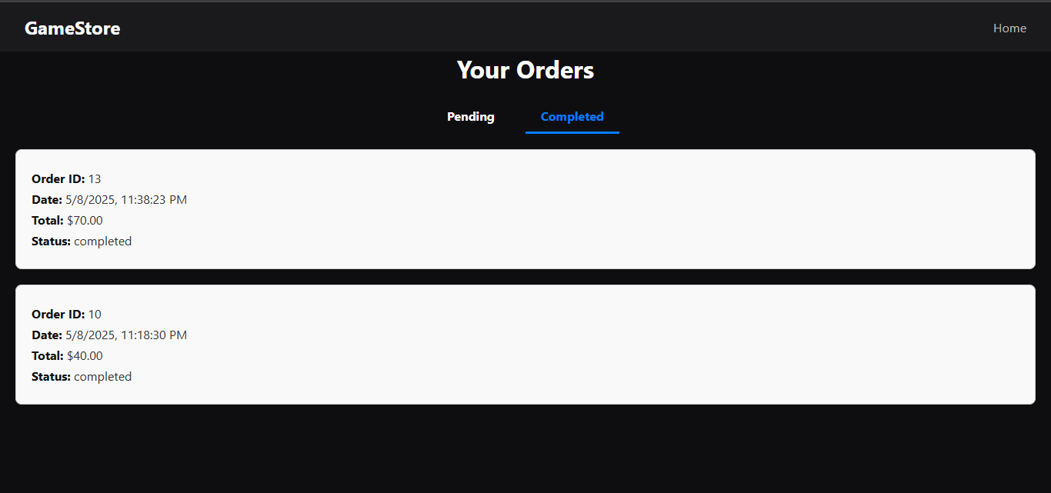

How the System Works
The Game Store application is an online platform where users can look at games, add them to a shopping cart, and make purchases. There’s also a section for admins to manage the game listings and keep track of orders. Here’s how it all works.

User Registration and Login
To use the app, users first need to create an account or log in if they already have one. When signing up, they provide a username, email, and password. The app checks to make sure the email looks right and the password is strong enough. For safety, the password isn’t saved as it is; instead, it’s turned into a secure code (hashed) that keeps it protected.
When logging in, users type in their email and password. The app compares the entered password with the stored (hashed) version to see if they match. If everything checks out, users can start browsing the store. Depending on whether they are a regular customer or an admin, they will see different features.

Game Browsing
Once logged in, users can explore the game collection. The homepage shows some featured games and lets users filter games by category, like Action or Adventure. There’s also a search bar to find a specific game by name. Clicking on a game shows more details, such as the title, description, price, and platform (like PC or console). If a game seems interesting, users can add it to their shopping cart.

Shopping Cart and Order Placement
The shopping cart is where users see all the games they’ve chosen. It shows the game names, prices, and how many of each they plan to buy. If users want to change the number of copies or remove a game, they can do so, and the total price updates right away.
When ready to buy, users go to the checkout page to see an order summary. This page shows the final list of games, their quantities, and the total amount. If everything looks good, they click the confirm button to place the order. The system then updates the database to record the purchase and reduce the inventory accordingly.

Payment
After confirming the order, users choose how they want to pay, like using a credit card or an online wallet. They enter their payment details, and once the payment goes through, the system updates the order status to "Paid" and shows a confirmation message. The payment information is also stored securely in the database.

Admin Functions
Admins have extra options compared to regular users. They can add new games to the store by entering details like the game’s title, price, genre, and platform. If game information needs to be updated, like changing the price or fixing a typo, admins can do that too. They can also remove games that are no longer available.
Admins can see a list of all customer orders, check their current status, and update them if needed (like marking an order as “Shipped” or “Delivered”). They can also handle cancellations or refunds when necessary.

Database Structure
The database keeps everything organized. It stores user information, game details, orders, and payment records. For example, the users table keeps track of who is logged in and whether they are a customer or an admin. The games table holds information like game ID, title, and price. The orders table links each order to a user and shows the order’s status and total amount. This setup makes it easy to find and manage data while keeping everything connected and organized.

